FAST FIT

GYM TRACKING APP

2019

CHAPTER 1 5

INTRODUCTION 5

1. BACKGROUND 5

2. OBJECTIVES 5

3. SCOPE 5

3.1. GYM WORKOUT TRACKER & TRAINER 5

3.2. DAILY WORKOUTS 6

3.3. FITNESS & BODYBUILDING 6

3.4. TECHNOLOGIES/RESOURCES 6

CHAPTER 2 7

REQUIREMENTS SPECIFICATION 7

1. PRODUCT PERSPECTIVE 7

1.1. PRODUCT FUNCTIONS 7

1.2. USER CHARACTERISTICS 7

2. EXTERNAL INTERFACE REQUIREMENTS 8

2.1. USER INTERFACE 8

2.2. HARDWARE INTERFACES 8

2.3. API INTERFACES 8

3. DATA REQUIREMENTS 9

3.1. USER DATA 9

3.2. WORKOUT PROGRAM DATA 9

4. FUNCTIONAL REQUIREMENTS 9

4.1. USER 9

4.2. CREATE AN ACCOUNT 9

4.3. LOGIN 10

4.4. SUBMIT EXERCISE PROGRAM 10

4.5. VIEW EXISTING PROGRAMS 10

4.6. RATE A PROGRAM 10

4.7. SAVE A PROGRAM TO PERSONAL LIST 11

4.8. EDIT PERSONAL PROGRAM 11

5. NON-FUNCTIONAL REQUIREMENTS 11

5.1. PORTABILITY 11

5.2. RELIABILITY 11

5.3. EASE OF USE 11

5.4. SPEED 11

5.5. SIZE 11

5.6. PRIVACY 12

CHAPTER 3 13

DESIGN PHASE 13

1. USE CASE INDEX 13

2. USE CASE DIAGRAM 14

3. UML CLASS DIAGRAM 14

CHAPTER 4 15

USER INTERFACE AND LAYOUT 15

CHAPTER 5 17

TESTING & USABILITY 17

1. BASIC TEST 17

1.1. TEST SCENARIO 17

1.2. TEST RESULTS 17

2. THINK ALOUD TEST 18

2.1. THINK ALOUD TASKS 18

2.2. THINK ALOUD TEST: RESULTS 18

3. PROJECT EVALUATION 19

4. CONCLUSION 19

CHAPTER 6 20

SYSTEM EVOLUTION AND REFERENCES 20

1. FURTHER DEVELOPMENT & RESEARCH 20

2. REFERENCES 20

# CHAPTER 1

# INTRODUCTION

Fast Fit is a community-based health and fitness mobile application. It aims to offer a social environment for people interested in health and fitness. The application will be fueled by user generated content, users will be able to submit and view exercise programs within the application. All programs in the application will be submitted by users of the application, so if a user finds a certain program works really well for them or finds a useful workout on the internet, they can submit it to the application for other users to try out. Users will be able to rate programs submitted to the application; this will help ensure high quality content within the application.

## BACKGROUND

Fast Fit aims to be a one stop workout companion for a user looking to exercise and improve their personal health. A survey carried out during the gathering of requirements showed a very positive response to the premise of using a mobile application for the purposes outlined above and an overwhelming majority confirmed they already use online sources to put together their workout programs. Respondents also agreed they were more likely to stick with exercising as part of a group or in collaboration with other people. These findings show that by combining all of the things people find useful into one application, It has the potential to fill a gap in the market and help people get active and improve their health.

## OBJECTIVES

The main focus of the application is to create a positive community for like-minded people to have a place to get together and help each other in achieving a common goal. The application will provide a discussion section where people can discuss the programs in the application and any other health and fitness topic they wish. Additionally, a one to one messaging system will be attempted, this serves many purposes but the main one is to help users pose any questions they may have about a program to its author.

## SCOPE

### GYM WORKOUT TRACKER & TRAINER

This application allows users to browse a list of premade programs and edit them if they wish. However, the list of programs on selection are static and won’t change dynamically. The application also does not offer any social or community-based functionality. It supports dynamic user generated content and has a virtually endless source of workout programs. It also offers social functionality to foster a sense of community and offer a positive environment to encourage exercising.

### DAILY WORKOUTS

This application supplies the user with premade, static workouts. The workouts provided are heavily focused around the idea of working out at home.

### FITNESS & BODYBUILDING

This application allows users to browse premade programs and to create their own. Users are not able to edit existing programs or submit their own for other users. The application also has no community functionality.

### TECHNOLOGIES/RESOURCES

|  |  |
| --- | --- |
| RESOURCE | DESCRIPTION |
| Windows Host Machine | Developing an Android applications requires the Java Integrated Development Environment. |
| Android Studio | Written in Java, requires an IDE that provides greater functionalities. We are using android 3.5.1. However, android 3 or above is recommended. |
| Physical Android/HAXM | Both, a physical android device or HAXM can be used to run and preview the development. |
| SQLite | An SQLite database, to store application data on device. |

# CHAPTER 2

# REQUIREMENTS SPECIFICATION

## PRODUCT PERSPECTIVE

The software will be written in Java using android Studio. It will run on android, Google’s Open-source mobile platform. It will provide users with the ability to find or submit workout routines inside the application. Users will be able to register an account and log in using their details to take part in an online community and gain access to user submitted content. Users can take part in public group discussions or one on one private conversations.

### PRODUCT FUNCTIONS

* Registered users will be able to register to the application with their personal details. Initially this will be via name only, but future changes could allow for Google and Facebook log in functionality.
* Users will be able to sign in and post a workout routine to the application for others to try out.
* Users will be able to sign in and browse a list of users submitted exercise programs and choose one they like to try out for themselves.
* Users will be able to sign in and browse a list of users submitted exercise programs and save them to their own personal list. This serves the purpose of allowing users to edit a routine they find to better suit their needs.
* Users of the application will be able to participate in group discussions within the application or opt to communicate one on one with another single user.
* Users will be able to apply positive or negative ratings to programs hosted within the application. This will help ensure the quality of the applications content and programs listed will be displayed by most positive votes, to most negative votes.
* Users will be able to use the application to find a Gym/Sports/Leisure Center nearby. This will be useful for people who are new to exercising as they may need to find a gym near their place of employment or their home.

### USER CHARACTERISTICS

#### UNREGISTERED USER

Unregistered users will not be able to gain access to the application or use any of its features. The whole focus of the application is on user submitted content and social interactions, none of this is possible without an account alias to tie a user to. Additionally, the services offered by the application will be behind a ToS (Terms of Service) agreement, this model was chosen as users will be following programs submitted by other users completely at their own risk. No liability is accepted by the developer of the application or any parties in connection with the developer.

#### REGISTERED USER

Registered users will gain full, non admin access to the application. Once a user registers their details and agrees to the ToS they will be able to post workout routines, view workout routines, rate workout routines, save routines to their personal list for edits, chat with other users and use the gyms nearby feature.

## EXTERNAL INTERFACE REQUIREMENTS

### USER INTERFACE

* The user interface shall offer the user a logical representation of what the software is asking the user to do. Dropdown menus and buttons should be used where possible to aid the user. Input hints shall be used to aid the user when entering data.
* The application should have its logo present on each screen once a logo has been designed.
* A user-friendly color scheme should be chosen, UI design should be carried out with visually impaired and color-blind users in mind.
* The UI should have well defined constraints to ensure that the software displays correctly on the screens of all compatible devices. The UI should display in both portrait and landscape.
* The GUI should have continuity, all screens should have the same design and layouts should be consistent.

### HARDWARE INTERFACES

* The system shall be operated with a compatible android device using the devices touch screen, virtual keyboard and GPS location hardware.

### API INTERFACES

* The software must store user information and user submitted content in local database to achieve communications between the database and the application.
* The software must show mapping information around the user’s current location using the Google maps API.

## DATA REQUIREMENTS

### USER DATA

* A user’s email address will need to be stored in order to give each user an alias to operate the application under. The email address will be used for account validation and to tie a user to their content.
* A user will need to create a password in order to verify themselves when accessing the system. The password will need to be stored in the system and tied to a user’s email address.

### WORKOUT PROGRAM DATA

* The application will need to manage the input and display of public workout programs.
* All public programs will be added to the application by the user and will be available for use by other users.
* Workout program data will include, but not be limited to, Workout Name, Workout Type, Workout Duration, Exercise Name, Exercise Sets, Exercise Reps and Exercise Instructions.
* The application will need to manage the input and display of personal workout programs.
* All personal programs will be saved from the public workouts section and edited by the user pulling down that data.
* Personal workouts will be stored separately to public workouts and are tied to an individual user and is only visible to them.
* Workout program data will include, but not be limited to, Workout Name, Workout Type, Workout Duration, Exercise Name, Exercise Sets, Exercise Reps and Exercise Instructions.

## FUNCTIONAL REQUIREMENTS

### USER

* All users of the software shall have the ability to create an account which is used to store user data and tie user actions to a user alias.
* User registration and login shall be mandatory.

### CREATE AN ACCOUNT

* The system should provide the user with an easy to use GUI to facilitate their creating an account.
* The system shall ask for an email address and password.
* The system shall notify the user if incorrect characters are used in the email or password fields.
* The system should notify the user if their email has already been used.
* The system should notify the user if any required fields are left empty.
* The system should not allow the user to create weak or unsecure passwords.
* The system should explain how the submitted password is unsecure.
* The system should prevent the user from completing registration if the terms of service has not been agreed to.

### LOGIN

* The system should provide a user-friendly GUI to allow the user to login when the application launches.
* The system should prompt the user for their email address and password.
* The system should notify the user if submitted information is incorrect.

### SUBMIT EXERCISE PROGRAM

* The system should provide an intuitive UI for logged in users to allow them to submit their exercise routine to the application.
* The system should prevent the user submitting a blank or empty routine.
* The system shall add successfully submitted routines to the local database.
* The system should display user submitted routines from the local database in the appropriate section of the application.

### VIEW EXISTING PROGRAMS

* The system should provide intuitive and user-friendly navigation to allow users to locate the current list of users submitted exercise routines.
* Once selected, the system shall retrieve all user submitted programs from the Google Firebase database and display them to the user.
* The system shall display full details of an exercise routine once one is selected by the user.
* The system should allow quick and easy navigation between different routines in the list.

### RATE A PROGRAM

* The system should provide a button to rate a program. Programs can be rated up or down based on the level of success the user has with them.
* Programs will be displayed based on ratings. Lower rated programs will be pushed to the bottom of the list before being removed.

### SAVE A PROGRAM TO PERSONAL LIST

* The system should provide a button to save a program from the public list of users submitted programs to their own personal list.
* Programs saved to a personal list are not visible to other users.

### EDIT PERSONAL PROGRAM

* The system should provide an intuitive and user-friendly UI to allow the user to view and manage their personal list of workout programs.
* The system should allow editing of programs saved to a user’s personal list.
* Multiple edits can be made, and all changes must be saved in real time

## NON-FUNCTIONAL REQUIREMENTS

### PORTABILITY

* The application will be written in JAVA using the JDK and JRE in android studio, the application will run natively on any android device running KitKat 4.4 or later.
* Additionally, Windows Bridge can be used to migrate the application to UWP and run on Windows 10 devices once development has finished.

### RELIABILITY

* The system should be extremely reliable and have an approximate up time of 99.999%.
* In the event of a crash or any other error, the System should inform the user of any problems and gracefully terminate.

### EASE OF USE

* The application should be user friendly and intuitive to use. GUIs should make their functions clear and navigation around the application should be straight forward.
* Users should be comfortable using the application after 20 minutes of use.

### SPEED

* The application should open and be ready to use within 10 seconds of being selected.
* The UI should be quick and smooth with no delays between button presses and screen reaction.
* All database reads/writes should take no longer than 5 seconds. If the database encounters any errors, a user-friendly warning should be displayed to the user.

### SIZE

* The size of the software in relation to storage media should be no larger than 250MB.

### PRIVACY

All data retained by the system will be stored in accordance with the Data Protection Act 1988 and the Data Protection (Amendment) Act 2003.

# CHAPTER 3

# DESIGN PHASE

## USE CASE INDEX

|  |  |  |  |  |  |
| --- | --- | --- | --- | --- | --- |
| Use Case ID | Use Case Name | Primary Actor | Scope | Complexity | Priority |
| 1 | Create Account | Unregistered User | In | Medium | High |
| 2 | Login | Registered User | In | Medium | High |
| 3 | Submit Program | Registered User | In | Medium | High |
| 4 | View Program | Registered User | In | Medium | High |
| 5 | Rate Program | Registered User | In | Low | Medium |
| 6 | Save Program | Registered User | In | High | Medium |
| 7 | Edit Program | Registered User | In | High | Medium |
| 8 | Send Message | Registered User | In | High | Medium |
| 9 | Find Gym | Registered User | In | Low | Medium |

## USE CASE DIAGRAM

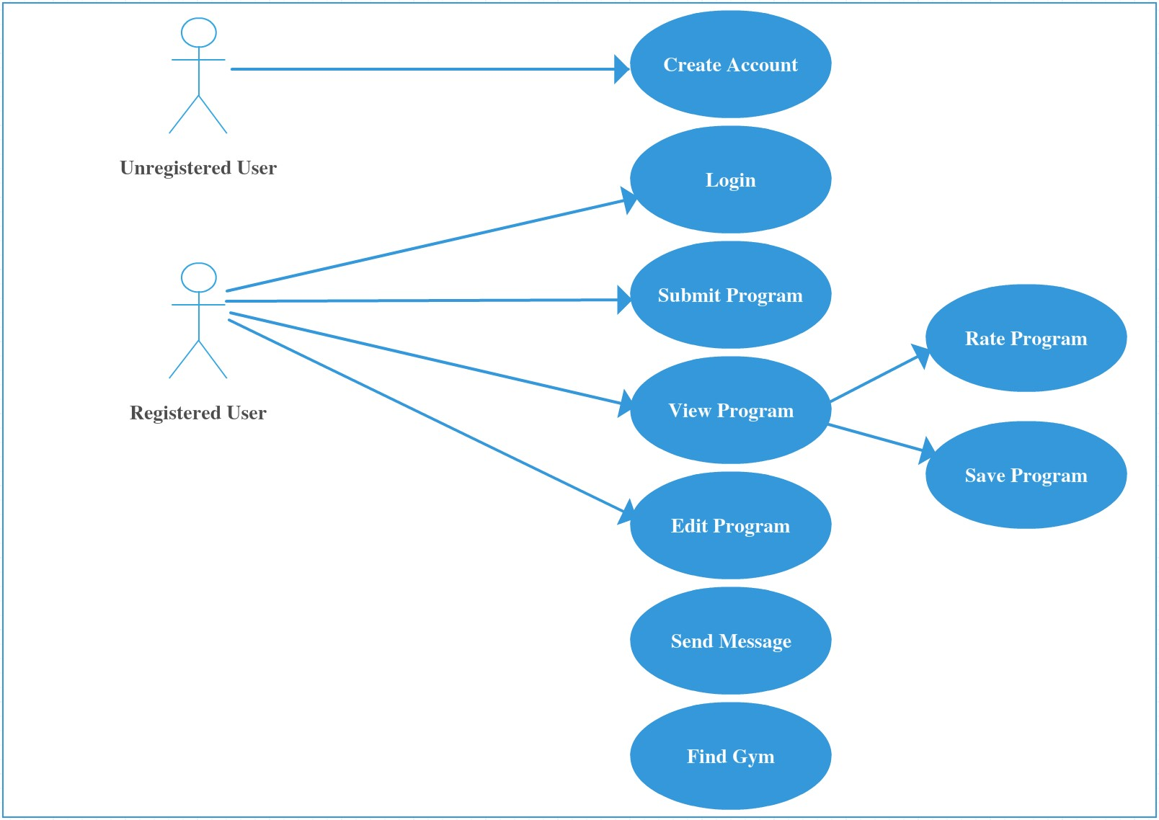

## UML CLASS DIAGRAM

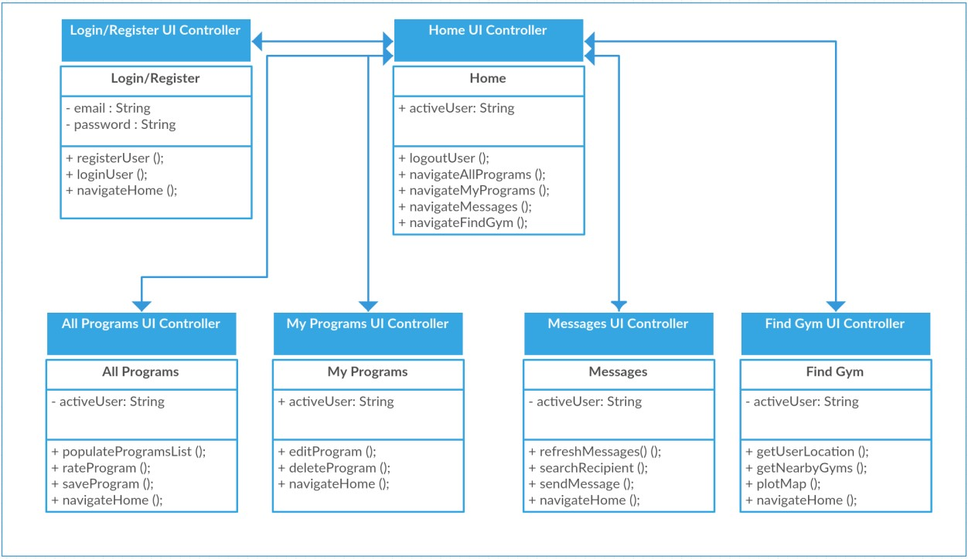

# CHAPTER 4

# USER INTERFACE AND LAYOUT

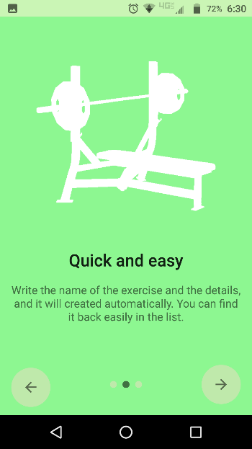 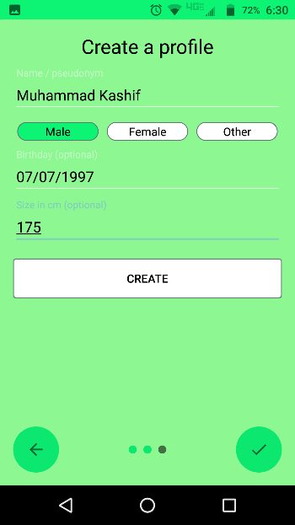 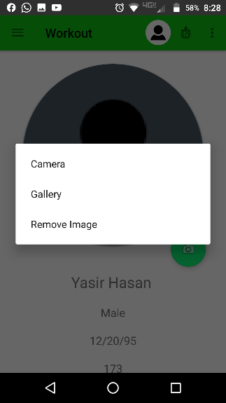

# CHAPTER 5

# TESTING & USABILITY

## BASIC TEST

### TEST SCENARIO

The goal of this test was to establish if the application’s design and key visual properties convey to the user the purpose of the application. From the 5 second test the user should be able to answer three crucial questions:

1. Who are you?
2. What product or service do you provide?
3. Why should I care (What is in it for me)?

To establish whether the application makes this information clear or not, several users took part in a 5 second test and were asked three questions once the time limit expired.

1. What do you think this application does?
2. What do you like most about this application?
3. What do you like least about this application?

### TEST RESULTS

|  |  |  |
| --- | --- | --- |
| What do you think this application does? | What do you like most about this application? | What do you like least about this application? |
| “Gym helper” | “Clear labeling” | “Have to log in” |
| “Workout assistant” | “Simple design” | “Nothing I can think of” |
| “I assume it is an exercise program manager” | “Divided into clear sections” | “Blue color scheme” |
| “Application for finding a gym buddy” | “Useful features” | “ Not really a topic that interests me as I don’t workout ” |
| “Allows you to make exercise programs” | “Good graphics” | “Can’t think of anything” |

## THINK ALOUD TEST

The think aloud tests provides a wealth of valuable information as it demonstrates a user’s thought process when interacting with an application. The think aloud test makes it possible to identify issues before a product goes live. A list of the most common functionality in the application was compiled and added to the think aloud test. Using this list of functionalities, questions were drawn up to evaluate the design and layout of the application.

### THINK ALOUD TASKS

* Create an account
* Login
* Create a workout program
* Browse public workout programs
* Save a public program to your private programs
* Browse community chat

### THINK ALOUD TEST: RESULTS

|  |  |
| --- | --- |
| Task | Result |
| Create an Account | Without hesitation the testers successfully created an account.  Required steps were taken quickly and efficiently. |
| Login | Without hesitation testers successfully logged in quickly with no issues. |
| Create a workout program | Testers completed task successfully on first attempt.  Some users were not sure of what to type in to some fields as they do not participate in exercise but they understood the principle. |
| Browse public workout programs | Testers completed task quickly without issues.  Testers commented on the navigation being easy due to the home page. |
| Save a public program to your private programs | Testers navigated to the public programs section and quickly identified the save button.  Testers successfully completed this task with little to no instructions. |
| Browse community chat | Some testers exhibited some slight hesitation regarding contacts list with the feature being a community chat.  Once it was explained that the list was to show active users, testers understood. |

## PROJECT EVALUATION

The project will be evaluated using unit tests, system tests and automation where possible. Primarily, testers will be sought out to participate in carrying out Quality Assurance (QA) Engineering on the project. Thanks to experience gained in carrying out QA on a regular basis during the work placement module, effective QA test plans will be drawn up and provided to participants in order for them to carry out thorough manual testing of the application.

## CONCLUSION

Overall, Fast Fit passed all the test successfully. When observing testers, no hesitation was displayed when identifying the type of application, they were presented with. All testers successfully identified the name of the application section they were in, what purpose it serves and what options they have in the given section of the application.

# CHAPTER 6

# SYSTEM EVOLUTION AND REFERENCES

## FURTHER DEVELOPMENT & RESEARCH

* Social Media Login functionality could be added at a later date.
* Some users are less likely to manually sign up for services with their email address and password.
* Having Social Media Login integration allows them to sign into the application without having to register an additional account.
* The application will be developed on android but could be ported to iOS as well once development is complete.
* While the application will be developed for android, it is possible to migrate the software Microsoft’s UWP using the Windows Bridge migration tool once development is complete.
* As a way of generating revenue in the future, in application advertisements could be implemented.
* Arrangements with Gyms and Health supplement companies could be reached to advertise their products and services in the application.

## REFERENCES

1. https://github.com/brodeurlv/fastnfitness
2. https://agilie.com/en/blog/fitness-activity-tracker-app-is-it-difficult-to-build-it
3. https://yalantis.com/blog/what-activity-tracking-technology-is-used-in-fitness-app-development/
4. https://archer-soft.com/en/blog/how-build-fitness-tracker-app
5. https://www.octalsoftware.com/health-fitness-app-development
6. https://www.cleveroad.com/blog/how-to-create-your-first-fitness-application